Lab Manual

**Object oriented programming**

**23CSE101**



Department of computer science of Engineering

Amrita School of Computing

Amrita Vishwa Vidyapeetham,

Amaravathi campus

Name: G.J.N.S.Chaitanya

Roll no:AV.SC.U4CSE24115

WEEK-1

Aim: To download and install JAVA Compiler on our laptops.

Procedure:

**Step1:** Search “JDK download” using a search engine

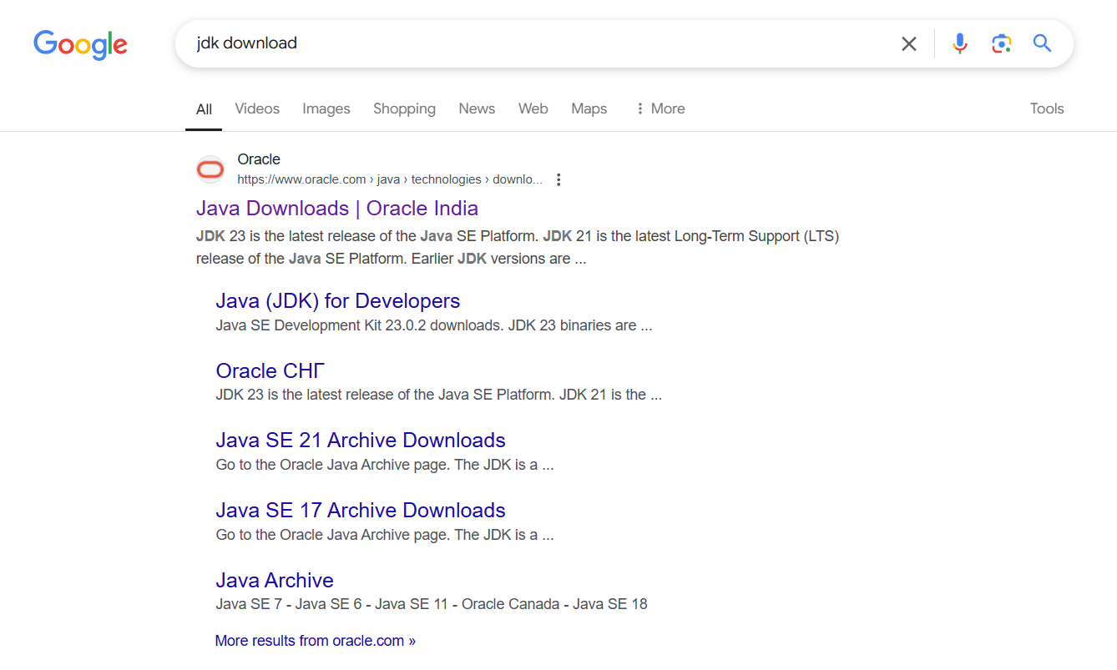

Step2: Click on the ORACEL website to download java

Step3: Select the 21.0.6 version which is suitable and stable for your system

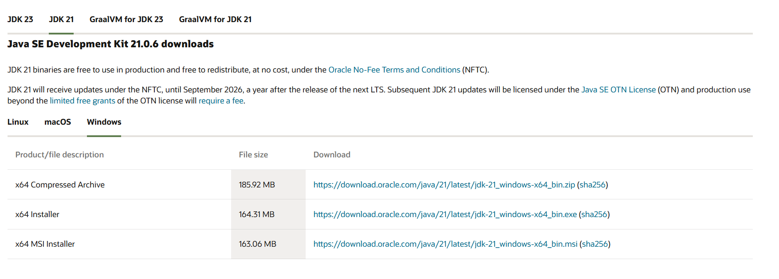

Step4: Choose the appropriate operating system

Step5: Start downloading.

Step6: Once downloaded, navigate to the downloads folder and open the file

Step7: Click Next, accept the terms and conditions, and proceed with the installation

Step8: Java compiler will now be installed successfully.

Step9: After installation, open environment variables by searching for it on your laptop

Step10: In environment variables, navigate to the system variables and select path option.

Step11: Click Edit, create a new path, and enter the required details.

Step12: Copy the path, Click OK, return to System variables, and add a new variable named JAVA_HOME.Paste the copied path and click OK to save.

Step13: To verify the installation, open the command prompt and check the java version using: java –version.



Step14: if the version is displayed, java has been successfully installed

AIM: To print the details of student using Java.

Procedure:

Step1: Open notepad and write the java code.

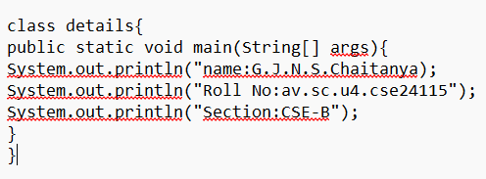

Step2: Save the file in a designated folder.

Step3: Open the command prompt.

Step4: Navigate to the file location and compile the code using: javac FILEname.java

Step5: After successful compilation, a.class file will be generated

Step 6: To see the output type java and file name in command prompt by java FILE name

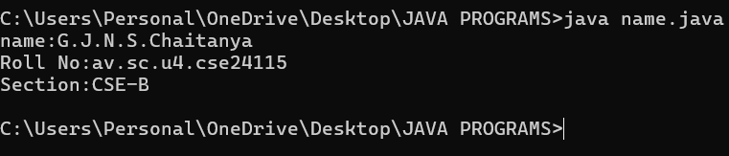

Step 7: The output will be displayed in the Command Prompt.

MY ERROR:

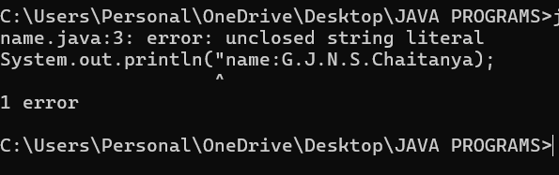

Ensure that after completion the statement close it with single or double quotes.

WEEK-2

1. AIM:

**Simple Java Program for finding simple interest by taking input from**

**User**

**Code:**

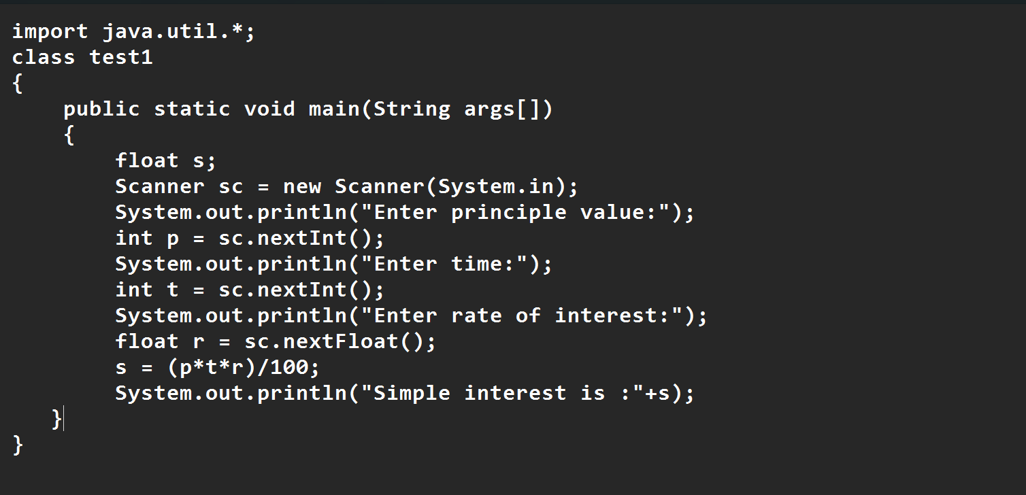

**Output:**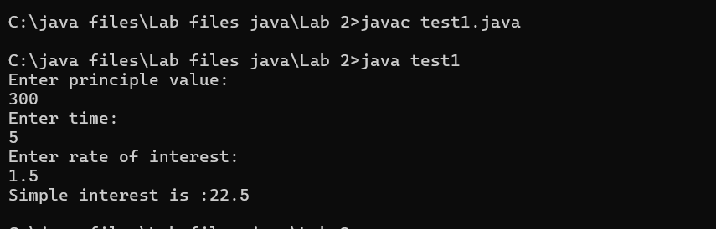

|  |  |  |  |
| --- | --- | --- | --- |
| **S.No** | **Error type** | **Reason for error** | **rectification** |
| **1** | **Runtime error** | **Incorrect path** | **Copied correct path** |
| **2** | **Syntax error** | **{ missing** | **{ added** |
| **3** | **Logical error** | **Wrong formula** | **Formula rectified** |
|  |  |  |  |

**2 )AIM:**

**.Write a simple program to calculate factorial of a number and read the**

**input from user**

**code:**

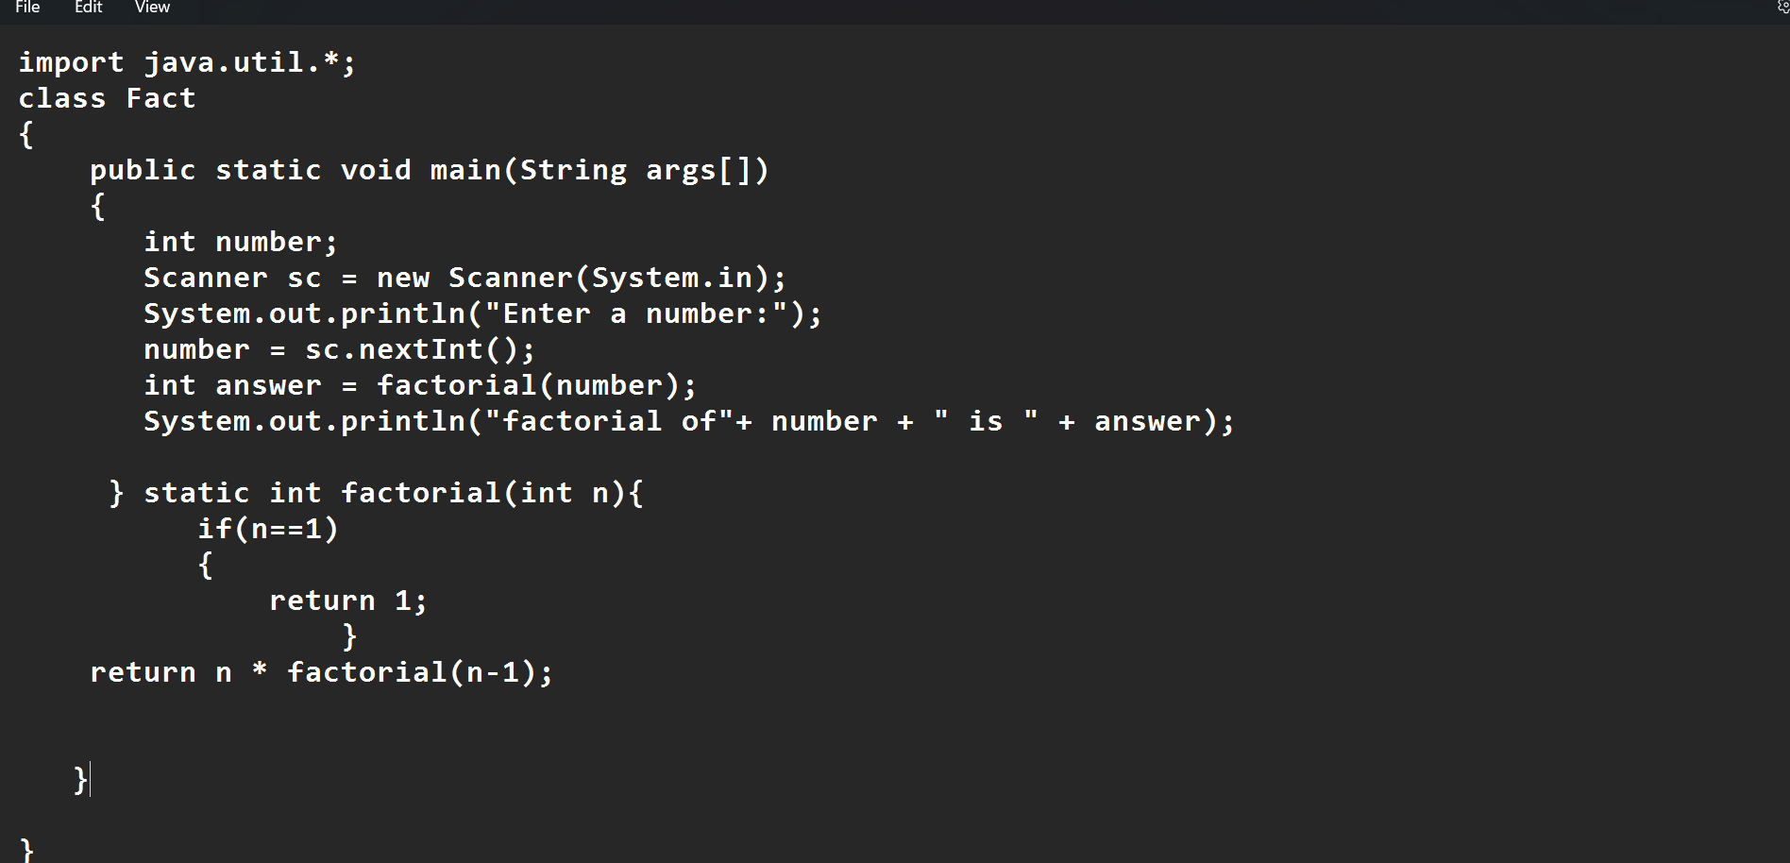

**Output:**

|  |  |  |  |
| --- | --- | --- | --- |
| **S.No** | **Error type** | **Reason for error** | **Rectification** |
| **1** | **Undeclared variable error** | **Missing variable** | **Variable declared** |
| **2** | **Missing import statement** | **Not importing packages** | **Packages imported** |
| **3** | **Logical error** | **Wrong formula** | **Formula rectified** |

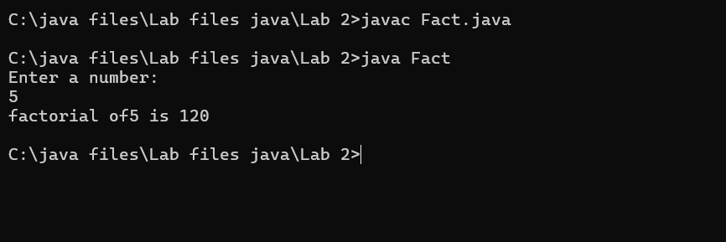

|  |  |  |  |
| --- | --- | --- | --- |
| **S.No** | **Error type** | **Reason for error** | **Rectification** |
| **1** | **Undeclared variable error** | **Missing variable** | **Variable declared** |
| **2** | **Missing import statement** | **Not importing packages** | **Packages imported** |
| **3** | **Logical error** | **Wrong formula** | **Formula rectified** |
|  |  |  |  |
|  |  |  |  |
|  |  |  |  |

**3) AIM:**

**Write a program to to calculate the fibonacii sequence and take the input from user**

**Code:**

**import java.util.*;**

**class fibo**

**{**

**public static void main(String args[])**

**{**

**Scanner sc = new Scanner(System.in);**

**int num;**

**int f3;**

**int f1 = 0;**

**int f2 = 1;**

**int i = 2;**

**System.out.print("Enter a number:");**

**num = sc.nextInt();**

**System.out.println(f1);**

**System.out.println(f2);**

**while(i<num)**

**{**

**f3 = f1+f2;**

**f1 = f2;**

**f2 = f3;**

**System.out.println(f3);**

**i = i+1;**

**}**

**}**

**}**

**Output:**

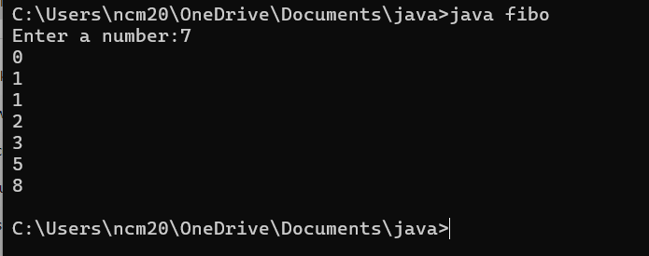

|  |  |  |  |
| --- | --- | --- | --- |
| **S.No** | **Error type** | **Reason for error** | **Rectification** |
| **1** | **Logical error** | **Incorrect formula** | **Formula rectified** |
| **2** | **Run-time error** | **Incorrect path** | **Added correct path** |
| **3** |  |  |  |

**5) AIM**

**Write a java program to convert temperature from Fahrenheit to celsius**

**Code:**

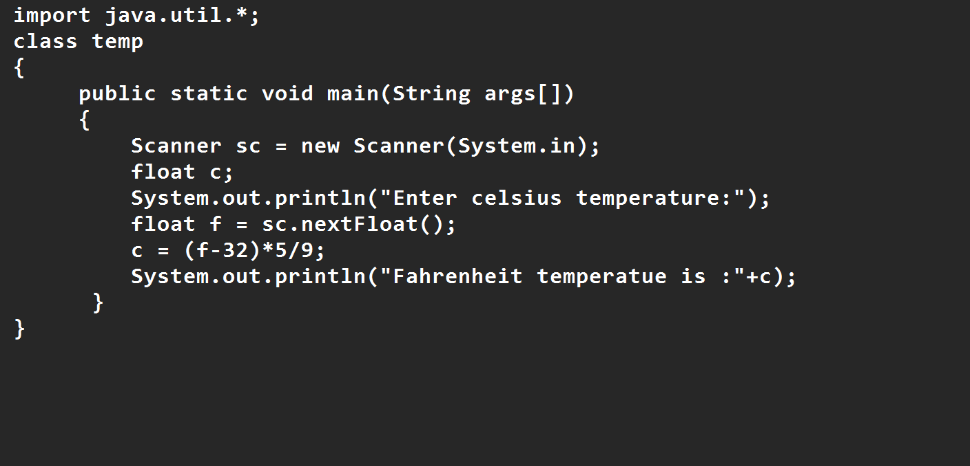

**Output:**

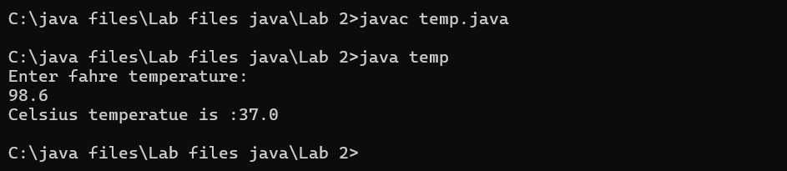

|  |  |  |  |
| --- | --- | --- | --- |
| **S.No** | **Error type** | **Reason for error** | **rectification** |
| **1** | **Syntax error** | **Missing ”** | **“ is added** |
| **2** | **Missing import error** | **Util package missing** | **Util package added** |
| **3** |  |  |  |

**AIM:**

**Write a java program to convert temperature from Celsius to Fahrenheit**

**Code**

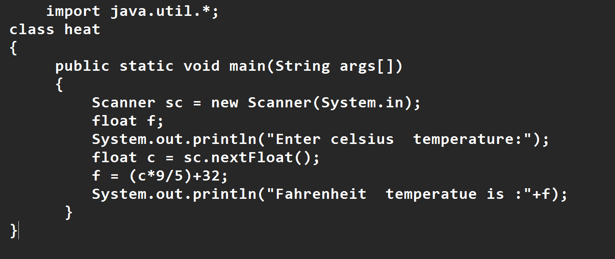

**Output:**

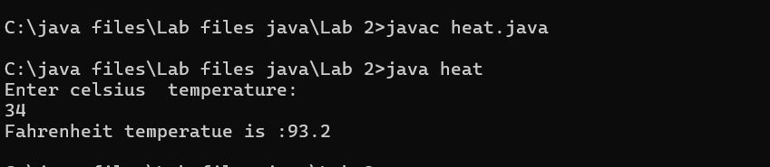

|  |  |  |  |
| --- | --- | --- | --- |
| **S.No** | **Error type** | **Reason for error** | **Rectification** |
| **1** | **Runtime error** | **Incorrect path selection** | **Correct path added** |
| **2** | **Logical error** | **Incorrect logic** | **Correct logic** |
| **3** |  |  |  |

**6) AIM:**

**Write a simple program to find the area of rectangle:**

**Code:**

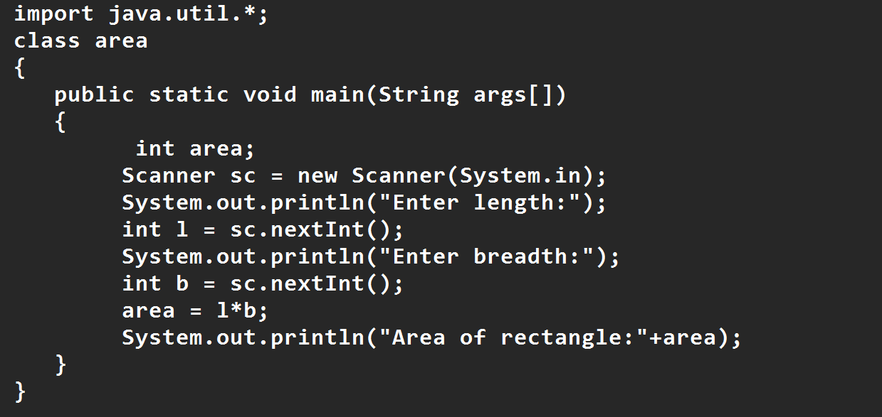

**Output:**

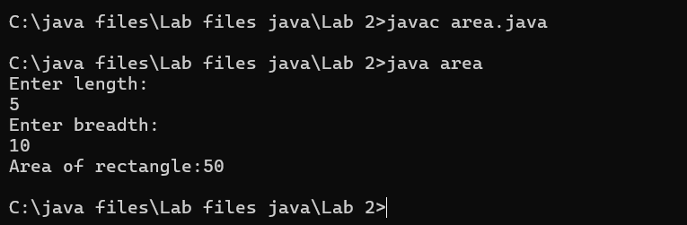

|  |  |  |  |
| --- | --- | --- | --- |
| **S.No** | **Error type** | **Reason for error** | **Rectification** |
| **1** | **Syntax error** | **Semi colon missing** | **Semi colon added** |
| **2** | **Missing import error** | **Import package missing** | **Import package added** |
| **3** |  |  |  |

**7)AIM:**

**Write a program to find the area of triangle by using heron’s formula take the input from the user**

**Code:**

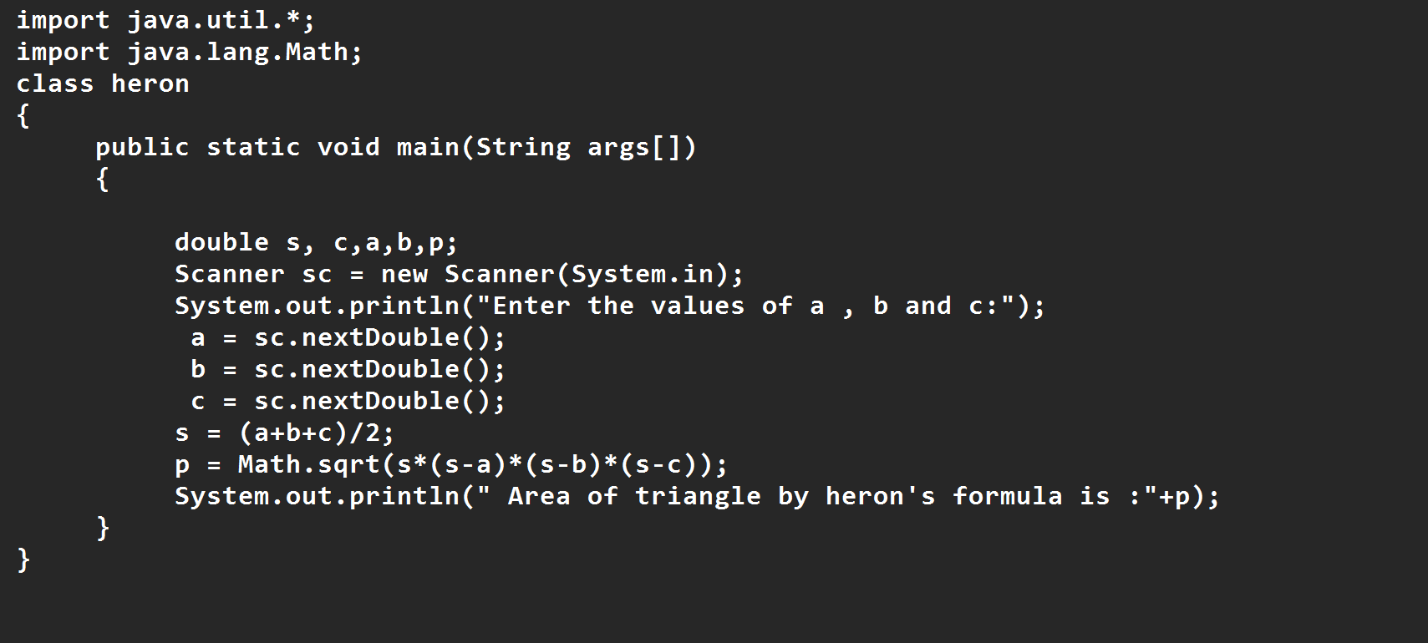

**OUTPUT:**

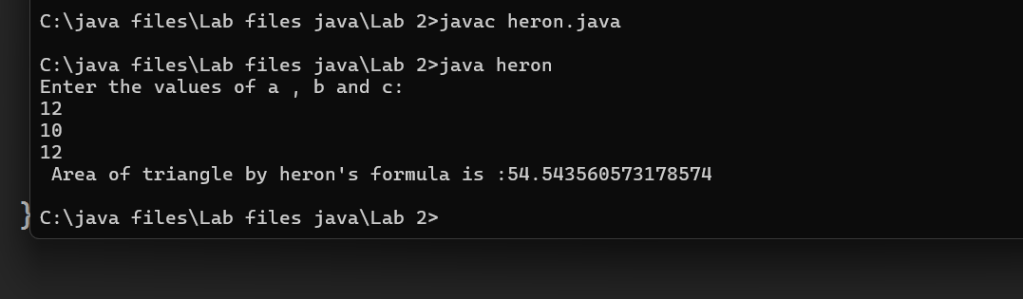

|  |  |  |  |
| --- | --- | --- | --- |
| **S.No** | **Error type** | **Reason for error** | **Rectification** |
| **1** | **Logical error** | **Incorrect formula** | **Formula rectified** |
| **2** | **Name error** | **Undeclared variable** | **Variable declared** |
|  |  |  |  |

**WEEK 3**

**Aim:**

**To create java program with following instructions**

**1.Create a class with name car**

**2. Create four attributes named car_color ,Car_brand,fuel_type,mileage**

**3. Create three methods named start(), stop(). Service()**

**4. Create three objects named car1,car2 and car3**

**import java.util.*;**

**class car**

**{**

**public String Car_color;**

**public String Car_brand;**

**public String fuel_type;**

**public int mileage;**

**public void start()**

**{**

**System.out.println("Car Started:");**

**System.out.println("Car color is :"+Car_color);**

**System.out.println("Car Brand is:"+Car_brand);**

**System.out.println("Car fuel type is:"+fuel_type);**

**System.out.println("Car mileage is:"+mileage);**

**}**

**public void service()**

**{**

**System.out.println("Car Started:");**

**System.out.println("Car color is :"+Car_color);**

**System.out.println("Car Brand is:"+Car_brand);**

**System.out.println("Car fuel type is:"+fuel_type);**

**System.out.println("Car mileage is:"+mileage);**

**}**

**public void stop()**

**{**

**System.out.println("Car Started:");**

**System.out.println("Car color is :"+Car_color);**

**System.out.println("Car Brand is:"+Car_brand);**

**System.out.println("Car fuel type is:"+fuel_type);**

**System.out.println("Car mileage is:"+mileage);**

**}**

**public static void main(String args[])**

**{ System.out.println("\n ncm\n\n");**

**car car1 = new car();**

**car1.Car_color = "Blue";**

**car1.Car_brand = "BMW";**

**car1.fuel_type = "Deisel";**

**car1.mileage = 10;**

**car1.start();**

**car car2 = new car();**

**car2.Car_color = "Red";**

**car2.Car_brand = "Tesla";**

**car2.fuel_type = "EV";**

**car2.mileage = 300;**

**car2.stop();**

**car car3 = new car();**

**car3.Car_color = "Yellow";**

**car3.Car_brand = "MAHINDRA";**

**car3.fuel_type = "Petrol";**

**car3.mileage = 20;**

**car3.service();**

**}**

**}**

**Output:**

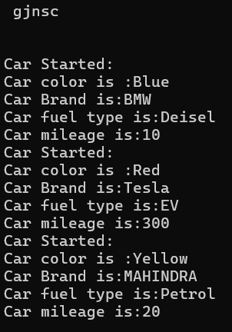

**Class Diagram**

|  |
| --- |
| **Car** |
| **+ car_color: String**  **+ car_brand: String**  **+ fuel_type: String**  **+ mileage: int** |
| **+ Car(): void**  **+ start(): void**  **+ service(): void**  **+ stop(): void** |

**2.AIM:**

**To create a class bankAccount with methods deposit() and withdrawl**

**Code:**

**class BankAccount {**

**private double balance;**

**public BankAccount(double initialBalance) {**

**if (initialBalance > 0) {**

**this.balance = initialBalance;**

**} else {**

**this.balance = 0;**

**}**

**}**

**public void deposit(double amount) {**

**if (amount > 0) {**

**balance = balance + amount;**

**System.out.println("Deposited $ " + amount);**

**} else {**

**System.out.println("Deposited amount must be positive");**

**}**

**}**

**public double getBalance() {**

**return balance;**

**}**

**}**

**public class Main {**

**public static void main(String args[]) {**

**BankAccount account = new BankAccount(1000);**

**account.deposit(500);**

**System.out.println("Current Balance is: $" + account.getBalance());**

**}**

**}**

**Output:**

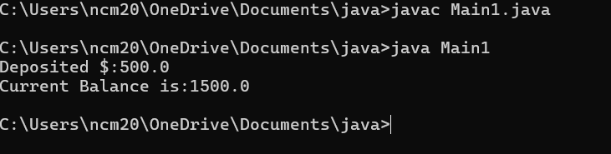

**ERRORS:**

|  |  |  |
| --- | --- | --- |
| **Sno.** | **Error message** | **Error rectification** |
| **1.** | **error: ';' expected**  **cust1.withdraw(3050)** | **Add a “;”**    **cust1.withdraw(3050);** |
| **2.** | **error: cannot find**  **symbol**  **thisCurrBal=CurrBal;** | **Add a “.”**    **this.CurrBal=CurrBal;** |

**WEEK-4**

**1.AIM:**

**WRITE A JAVA PROGRAM WITH CLASS NAMED “Book”. THE CLASS SHOUKD CONTAIN VARIOUS ATTRIBUTES SUCH AS TITLE, AUTHOR, YEAR OF PUBLICATION. IT SHOULD ALSO CONTAIN A CONSTRUCTOR WITH PARAMETERS WHICH INITIALIZES TITLE, AUTHOR, YEAR OF PUBLICATION AND CREATE A METHOD WHICH DISPLAYS THE DETAILS OF 2 BOOKS.**

**PROGRAM:**

public class Book {

public String title;

public String author;

public int year;

Book(String title, String author, int year) {

this.title = title;

this.author = author;

this.year = year;

}

public void displayDetails() {

System.out.println("Title: " +title);

System.out.println("Author: " +author);

System.out.println("Year of Publication" +year);

}

public static void main(String[] args) {

Book b1 = new Book("Math", "Ramanujan", 1950);

Book b2 = new Book("Physics", "CV Raman", 1960);

b1.displayDetails();

b2.displayDetails();

}

}

Output:

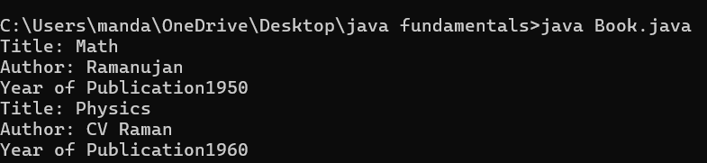

NEGATIVE CASE:

ERROR:

|  |  |  |  |
| --- | --- | --- | --- |
| S.No | ERROR TYPE | Reason for error | Rectification |
| 1. | Syntax error | No semicolon | Semicolon added |
| 2. | Runtime error | Incorrect path | Copied correct path |

CLASS DIAGRAM:

|  |
| --- |
| Book |
| -title: String  -author: String  -year: int |
| + Book(title: String, author:String, year: int) + displayDetails(): void |

**2.AIM:**

**WRITE A JAVA PROGRAM WITH CLASS NAMED “MyClass” WITH STATIC VARIABLE COUNT OF INT TYPE INTIALIZE IT TO ZERO AND CONSTANT “Pi” OF TYPE DOUBLE INITIALIZED TO “3.14” AS ATTRIBUTES OF THAT CLASS. NOW DEFINE A CONSTRUCTOR FOR “MyClass”, THAT INCREMENTS THE COUNT VARIABLE EACH TIME AN OBJECT OF “MyClass” IS CREATED. FINALLY, PRINT THEFINAL VALUES OF ‘COUNT’ AND ‘PI’ VARIABLES AND CREATE 3 OBJECTS.**

**PROGRAM:**

public class MyClass {

static int count = 0;

static final double pi = 3.14;

MyClass() {

count++;

}

public static void main(String[] args) {

MyClass obj1 = new MyClass();

MyClass obj2 = new MyClass();

MyClass obj3 = new MyClass();

System.out.println("Count: " +count);

System.out.println("Pi: " +pi);

}

}

OUTPUT:

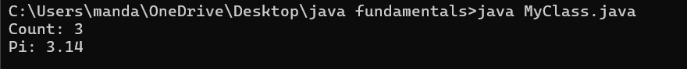

NEGATIVE CASE:



ERROR:

|  |  |  |  |
| --- | --- | --- | --- |
| S.No | Error Type | Reason for error | Rectification |
| 1. | No class | No class name declared | Created class named ‘MyClass’ |
| 2. | Syntax error | Not added keyword | Added keyword named ‘new’ |
|  |  |  |  |

CLASS DIAGRAM:

|  |
| --- |
| MyClass |
| -count: int (static)  -pi: double (static, final) |
| +MyClass()  +main(args: String[]):void |